SRS Report
On
Project Management & Repository System

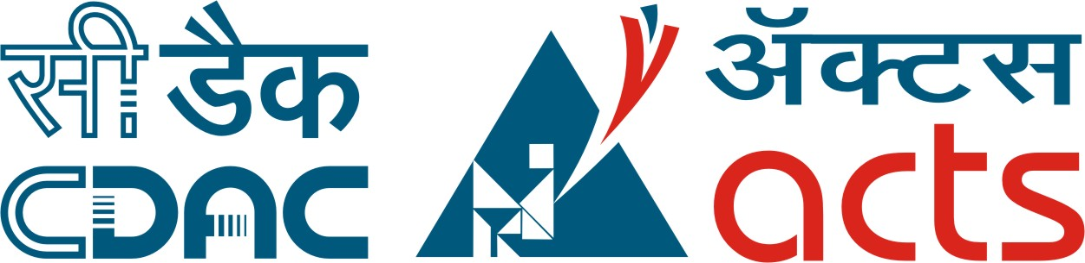

Submitted in partial fulfillment for the award of
Post Graduate Diploma in Advance Computing
(PG-DAC) from C-DAC ACTS (Pune)

Guided by:

Mr. Bafna

Presented by:

Arunendra Kumar Prn: 190240120027

Ashutosh Vaish Prn: 190240120027

Gaurav Mittal Prn: 190240120027
Shaswat Prn: 190240120027
Shipra Prn: 190240120027
Ramandeep Prn: 190240120027

Centre for Development of Advanced Computing (C-DAC), Pune

